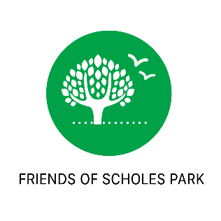**AGENDA**

**MEETING FRIENDS OF SCHOLES PARK**

**Thursday 23rd May 8pm**

Venue: GATLEY ELM ROAD URC CHURCH HALLS

1. Welcome and Introductions
2. Ongoing Projects
   1. Children’s craft/consultation stalls. Gatley sports day and Gatley Festival Teddy Bears Picnic
   2. Community Planting Area
      1. Successful Ward Flexibility Fund Application £1000
      2. Details of Plans
      3. Planned working days – draft application made to council (for installation work with contractor and Kingsway students w.c. 17th June, children’s planting activities and community activities 5&6th July)
      4. Use of contractors – feedback from Jacky Budd, Greenspace Project Officer
      5. Plans for additional funding required
   3. Children’s Trail
      1. Plans for trail
      2. Use of local craftsman
      3. Plans for funding required
3. Control of Dogs – Feedback from Jacky Budd, and questions raised to Richard Booker, Playgrounds Officer
4. Long term plans for running track
5. Long term plans for children’s play park
6. Funding application opportunities
   1. Manchester airport (for information signs)
   2. Gatley URC Dunham Fund
   3. Stockport Homes Community Fund
   4. Wooden Spoon Grants
   5. Running Bee Grant
   6. Tesco bags for Life
7. Any Other Business
   1. Facebook page over 100 members :o)
   2. Setting up email/website
   3. Next FOSP meeting