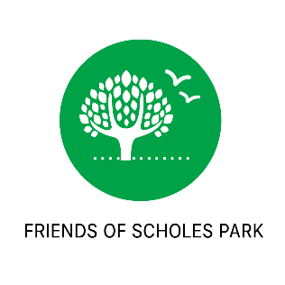**AGENDA**

**MEETING FRIENDS OF SCHOLES PARK**

**15th April 2021 8.30pm**

Venue: ZOOM MEETING

1. Introductions

Apologies

Actions from last meeting covered in relevant sections in the agenda

1. Recent Events
   1. Easter Trial
2. Information Sign install update
   1. Art in the park competition
3. Funding
   1. Activity trail funds raised so far – Update from SG
      1. Plan for charity collection tins in local shops
      2. Calendar idea. VH to progress
      3. Further funding applications made
      4. Other application and fundraising opportunities
   2. Police Community Fund Application Successful. £200 for plants, soil, and fruit bushes
   3. Stockport Hydro Environmental Challenge Fund Application Successful. £200 for Christmas lantern event
4. Running Track Update
5. City of Trees Update
6. Manchester black poplars – rare trees in Gatley Hill House grounds
7. Community Orchard Update
   1. Action from last meeting to consider planting of fruit bushes ahead of planned orchard area BH&JO
8. Requirement for all weather paths for access into and around the park
   1. SG and GW to put path improvement detail onto park plan and SG to submit proposal to council (see SGs proposal)
9. Protecting green spaces in terms of the spatial framework changes
   1. BH and RK to progress fields in trust application.
   2. After General discussion on actual ownership of Scholes park at last meeting. KH and GG to raise with the Council Legal Officer on behalf of FOSP.
10. Fly tipping campaign
    1. JO and VH to work on posters for campaign
11. Encouraging responsible dog ownership
    1. Additional signage
    2. Stopping littering with poo bags
    3. Idea for dedicated dog area/ dog agility equipment
12. Off-road motor bike issue
13. Path improvements – update from meeting arranged by councillors with council and local residents
14. Update on SMART planned archaeological dig application.
15. Planned events.
    1. Events for summer to be considered including maintaining the planters with schools or further planting along new path, or fruit bushes area, storytelling event, family picnic, mile run event.
    2. Christmas lantern event planned.
16. Any Other Business
    1. Next FOSP meeting.